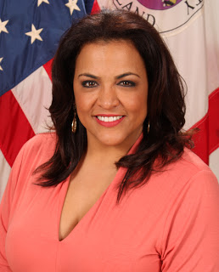

Jennifer Donelan
Prince George’s County Police
Director, Media Relations Division

Jennifer Donelan, a former Emmy award winning broadcast journalist, is the Director of the Media Relations Division at Prince George’s County Police. She joined the agency in November of 2016 after a twenty year career in television news. From the moment she walked in the doors at headquarters, she hit the ground running beginning with the opening of the MGM Grand National Harbor Resort & Casino, one the largest economic investments in the county’s history. Under the leadership of Chief Hank Stawinski, Donelan has steered the agency through numerous headline grabbing cases, most tragic of which was the line of duty death of Prince George’s County Police Sergeant Mujahid Ramzziddin in February, 2018.

Her TV career began in 1996 as the 5 o’clock co-anchor at WAFB TV in Baton Rouge, Louisiana. From there she moved to Detroit, Michigan where she was the lead crime reporter for WDIV-TV. Her work there catapulted her to a national correspondent position with CBS Newspath where she traveled across the country and around the world covering events such as the 2004 Presidential campaign, the Michael Jackson, Kobe Bryant, and DC Sniper trials, two space shuttle launches, the death of Pope John Paul II, and several major hurricanes including Katrina. Donelan then joined ABC 7 in Washington DC where she served as the lead city crime reporter and, finally, as the 7 On Your Side “Fighting Back” Against Crime investigator.

Jennifer is a proud member of the National Information Officers Association, International Association of Chiefs of Police, National Association of Black Journalists, and the Potomac Chapter of the Links, Inc.

