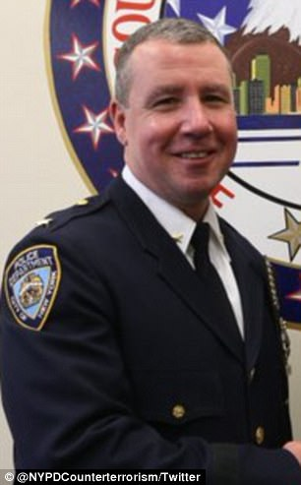 **SCOTT A. SHANLEY**

**Deputy Chief**

**New York City Police Department**

Deputy Chief Shanley is a thirty year veteran of the NYPD and is currently assigned as the Commanding Officer of the Counterterrorism Bureau’s Critical Response Command. The Critical Response Command is comprised of 525 highly trained and equipped officers assigned to proactively deploy to locations such as critical infrastructure, iconic locations, mass transit facilities and other locations identified as possible targets throughout New York City. This deployment is designed to prevent, deter, detect or disrupt and if necessary mitigate terrorist attacks. Prior to this assignment Chief Shanley served as the Commanding Officer of the Transit Bureau’s Counterterrorism Unit. In this position he was responsible to coordinate all Transit Counterterrorism operations. Additionally, Chief Shanley commanded the 30th and 104th Precincts where during his tenure he achieved a 40% decrease in violent crime. Deputy Chief Shanley has received over 30 medals for excellence, meritorious duty, community service and a unit citation. Deputy Chief Shanley possesses a bachelor’s degree in political science from Gettysburg College, a graduate certificate in police management from Columbia University’s Police Management Institute and a graduate certificate in Homeland Security from the Naval Post Graduate School.